关系模式图

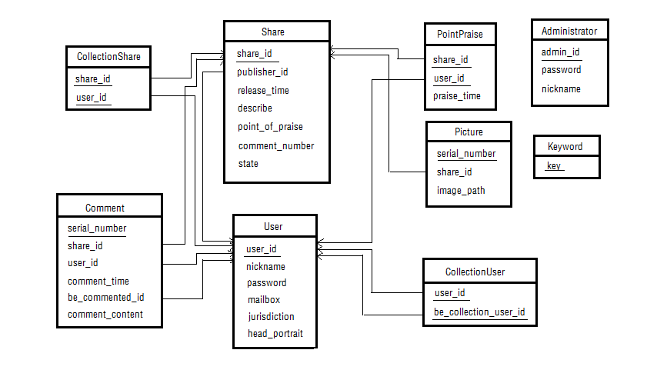

ER图

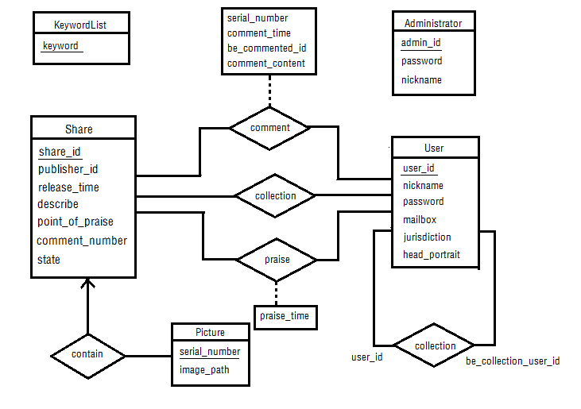

建表：

1、用户表（user）

CREATE TABLE `ishow`.`user`(

`user_id` INT UNSIGNED NOT NULL AUTO_INCREMENT,

`nickname` VARCHAR(20) NOT NULL,

`password` VARCHAR(20) NOT NULL,

`mailbox` VARCHAR(30) NOT NULL,

`jurisdiction` INT NOT NULL DEFAULT 0,

`head_portrait` VARCHAR(100) NULL,

PRIMARY KEY (`user_id`)

) ENGINE=INNODB CHARSET=utf8 COLLATE=utf8_general_ci;

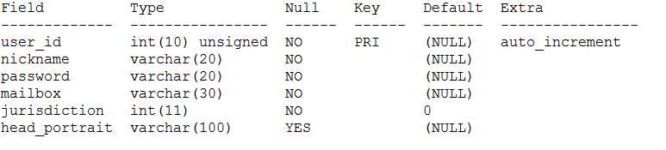

2、分享表（share）

CREATE TABLE `ishow`.`share`(

`share_id` INT UNSIGNED NOT NULL AUTO_INCREMENT,

`publisher_id` INT UNSIGNED NOT NULL,

`release_time` DATETIME NOT NULL,

`describe` TEXT,

`point_of_praise` INT NOT NULL DEFAULT 0,

`comment_number` INT NOT NULL DEFAULT 0,

`state` INT NOT NULL DEFAULT 0,

PRIMARY KEY (`share_id`),

FOREIGN KEY (`publisher_id`) REFERENCES `ishow`.`user`(`user_id`) ON UPDATE CASCADE ON DELETE CASCADE

)ENGINE=INNODB CHARSET=utf8 COLLATE=utf8_general_ci;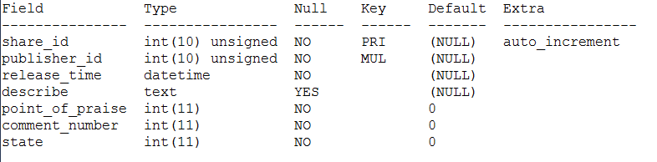

3、图片表（picture）

CREATE TABLE `ishow`.`picture`(

`serial_number` INT UNSIGNED NOT NULL AUTO_INCREMENT,

`share_id` INT UNSIGNED NOT NULL,

`image_path` VARCHAR(100) NOT NULL,

PRIMARY KEY (`serial_number`),

FOREIGN KEY (`share_id`) REFERENCES `ishow`.`share`(`share_id`) ON UPDATE CASCADE ON DELETE CASCADE

) ENGINE=INNODB CHARSET=utf8 COLLATE=utf8_general_ci;

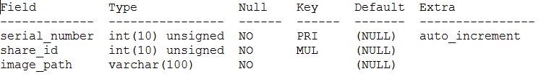

4、点赞表（PointPraise）

CREATE TABLE `ishow`.`PointPraise`(

`share_id` INT UNSIGNED NOT NULL,

`user_id` INT UNSIGNED NOT NULL,

`praise_time` DATETIME NOT NULL,

PRIMARY KEY (`share_id`, `user_id`),

FOREIGN KEY (`share_id`) REFERENCES `ishow`.`share`(`share_id`) ON UPDATE CASCADE ON DELETE CASCADE,

FOREIGN KEY (`user_id`) REFERENCES `ishow`.`user`(`user_id`) ON UPDATE CASCADE ON DELETE CASCADE

) ENGINE=INNODB CHARSET=utf8 COLLATE=utf8_general_ci;

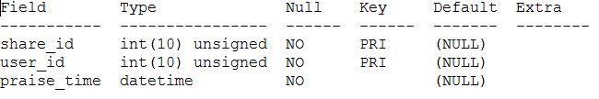

5、收藏分享表（CollectionShare）

CREATE TABLE `ishow`.`CollectionShare`(

`share_id` INT UNSIGNED NOT NULL,

`user_id` INT UNSIGNED NOT NULL,

PRIMARY KEY (`share_id`, `user_id`),

FOREIGN KEY (`share_id`) REFERENCES `ishow`.`share`(`share_id`) ON UPDATE CASCADE ON DELETE CASCADE,

FOREIGN KEY (`user_id`) REFERENCES `ishow`.`user`(`user_id`) ON UPDATE CASCADE ON DELETE CASCADE

) ENGINE=INNODB CHARSET=utf8 COLLATE=utf8_general_ci;

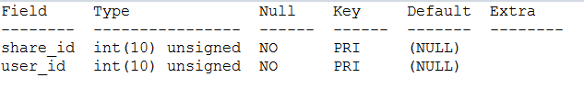

6、收藏用户表（CollectionUser）

CREATE TABLE `ishow`.`CollectionUser`(

`user_id` INT UNSIGNED NOT NULL,

`be_collection_user_id` INT UNSIGNED NOT NULL,

PRIMARY KEY (`user_id`, `be_collection_user_id`),

FOREIGN KEY (`user_id`) REFERENCES `ishow`.`user`(`user_id`) ON UPDATE CASCADE ON DELETE CASCADE,

FOREIGN KEY (`be_collection_user_id`) REFERENCES `ishow`.`user`(`user_id`) ON UPDATE CASCADE ON DELETE CASCADE

) ENGINE=INNODB CHARSET=utf8 COLLATE=utf8_general_ci;

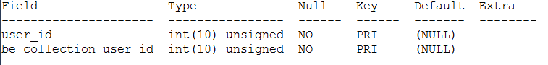

7、评论表（Comment）

CREATE TABLE `ishow`.`Comment`(

`serial_number` INT UNSIGNED NOT NULL AUTO_INCREMENT,

`share_id` INT UNSIGNED NOT NULL,

`user_id` INT UNSIGNED NOT NULL,

`comment_time` DATETIME NOT NULL,

`be_commented_id` INT UNSIGNED,

`comment_content` TEXT NOT NULL,

PRIMARY KEY (`serial_number`),

FOREIGN KEY (`share_id`) REFERENCES `ishow`.`share`(`share_id`) ON UPDATE CASCADE ON DELETE CASCADE,

FOREIGN KEY (`user_id`) REFERENCES `ishow`.`user`(`user_id`) ON UPDATE CASCADE ON DELETE CASCADE,

FOREIGN KEY (`be_commented_id`) REFERENCES `ishow`.`user`(`user_id`) ON UPDATE CASCADE ON DELETE CASCADE

) ENGINE=INNODB CHARSET=utf8 COLLATE=utf8_general_ci;

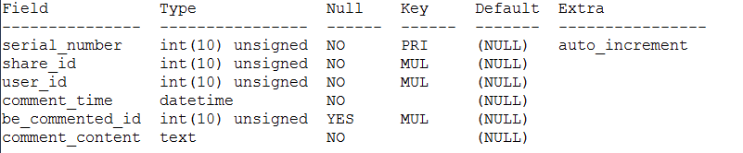

8、管理员表（Administrator）

CREATE TABLE `ishow`.`Administrator`(

`admin_id` INT UNSIGNED NOT NULL AUTO_INCREMENT,

`password` VARCHAR(20) NOT NULL,

`nickname` VARCHAR(20) NOT NULL,

PRIMARY KEY (`admin_id`)

) ENGINE=INNODB CHARSET=utf8 COLLATE=utf8_general_ci;

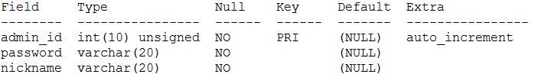

9、关键字表（Keyword）

CREATE TABLE `ishow`.`Keyword`(

`key` VARCHAR(20) NOT NULL,

PRIMARY KEY (`key`)

) ENGINE=INNODB CHARSET=utf8 COLLATE=utf8_general_ci;

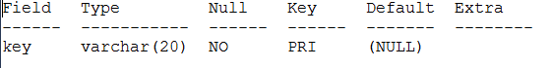

触发器1（点赞表增加，对应的分享表里的点赞数+1）

DELIMITER $$

USE `ishow`$$

DROP TRIGGER /*!50032 IF EXISTS */ `trigger_01`$$

CREATE

/*!50017 DEFINER = 'root'@'localhost' */

TRIGGER `trigger_01` AFTER INSERT ON `pointpraise`

FOR EACH ROW BEGIN

UPDATE `ishow`.`share` SET point_of_praise=point_of_praise+1

WHERE new.share_id=`ishow`.`share`.`share_id`;

END;

$$

DELIMITER ;

触发器2（点赞表增加，对应的分享表里的点赞数-1）

DELIMITER $$

CREATE

/*[DEFINER = { user | CURRENT_USER }]*/

TRIGGER `ishow`.`trigger_02` AFTER DELETE

ON `ishow`.`PointPraise`

FOR EACH ROW BEGIN

UPDATE `ishow`.`share` SET point_of_praise=point_of_praise-1

WHERE old.share_id=`ishow`.`share`.`share_id`;

END$$

DELIMITER ;

触发器3（评论表增加，对应的分享表里的评论数+1）

DELIMITER $$

USE `ishow`$$

DROP TRIGGER /*!50032 IF EXISTS */ `trigger_03`$$

CREATE

/*!50017 DEFINER = 'root'@'localhost' */

TRIGGER `trigger_03` AFTER INSERT ON `comment`

FOR EACH ROW BEGIN

UPDATE `ishow`.`share` SET comment_number=comment_number+1

WHERE new.share_id=`ishow`.`share`.`share_id`;

END;

$$

DELIMITER ;

触发器4（评论表增加，对应的分享表里的评论数-1）

DELIMITER $$

USE `ishow`$$

DROP TRIGGER /*!50032 IF EXISTS */ `trigger_04`$$

CREATE

/*!50017 DEFINER = 'root'@'localhost' */

TRIGGER `trigger_04` AFTER DELETE ON `comment`

FOR EACH ROW BEGIN

UPDATE `ishow`.`share` SET comment_number=comment_number-1

WHERE old.share_id=`ishow`.`share`.`share_id`;

END;

$$

DELIMITER ;

补充：

ALTER TABLE `user` ADD UNIQUE(`mailbox`);